211 Team One Fall 2020 Shakespearean Insult Selector ReadMe with Instructions for Use

211 Team One is: Zach Clevenger, Angela Johnson, Amber Ferrebee

Welcome to the Shakespearean Insult Selector!

This program aims to provide the user with an insult from Shakespeare’s works via a quiz about their opponent.

There are several classes involved with this program.

* QuestionsaNSWERScreates an array that holds the text of the questions and answer choices used in the quiz.
* Insults creates an array of the Insults used.
* AnalyseAnswers calculates the sum of the user’s answer’s values as well as their average. It also uses a random number generator that returns a number between one and 10.
* Choices takes the average from Analyse Answers and uses it to determine what intro text to display in the “results” area.
* It also takes the random integer generated in Analyse Answers and uses that to determine which of the 10 insults in the insults array will be displayed.
* UseInsult was the class that we used to test the logic for the program.
* useShakespeareInsultGUI contains the code for displaying the questions and choices and the buttons that the user uses to make their choices.
* mainGUI contains the opening scene that invites the user to take the quiz. When the user clicks on the “Take Quiz” button, the useShakespeareGUI scene opens and the user proceeds as per the instructions above.

When the user makes a selection by clicking either the 1, 2, or 3 button, that button’s value is added to an integer array, the counter variable is advanced by 1, and the scene is refreshed with the next question in the array containing the questions and answers.

When the last question has been answered, the sum and average of the answer values is calculated and the random number is generated.

These values are passed into the Choices class and the into and Insult are then displayed in the GUI.

See instructions for use beginning on the next page.

INSTRUCTIONS FOR USE

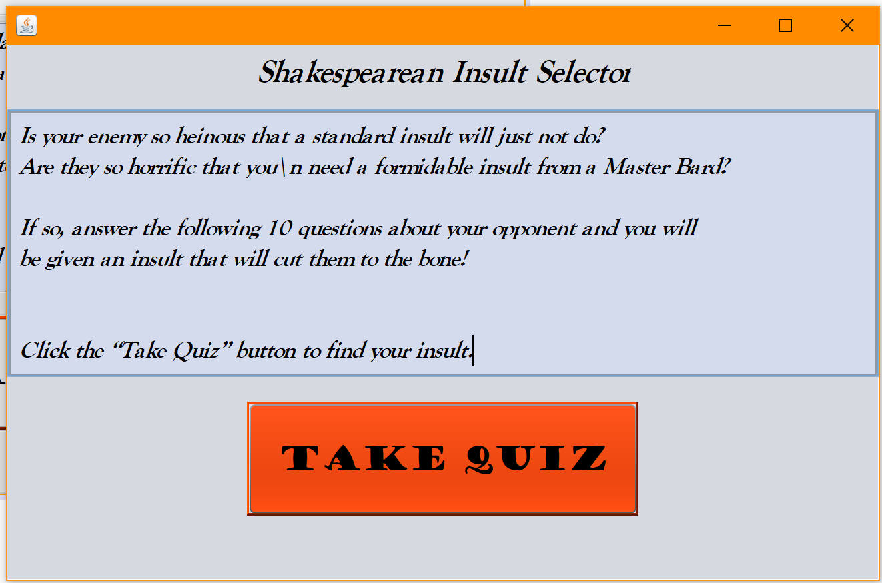

The first thing you will see is the into window.

To take the quiz press the red “Take Quiz” button.

You may also click the “X” in the upper right hand corner of the window to exit the program,

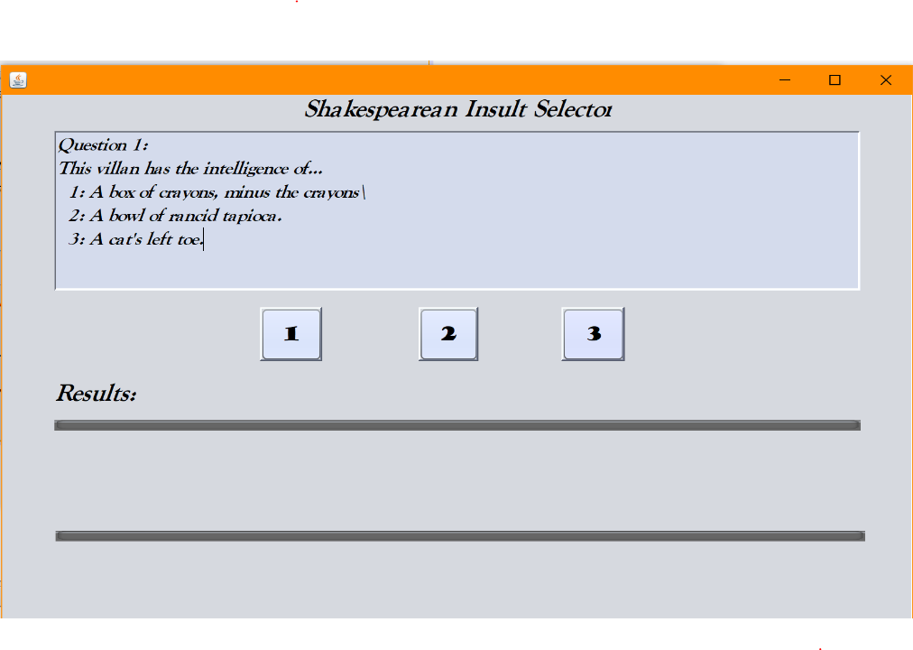This window will open.

After you read the questions, press the button that matches the number to the left of your selected answer.

Repeat until you have answered all 10 questions.

After you answer the 10th questions, your insult will appear in the “Results” area.

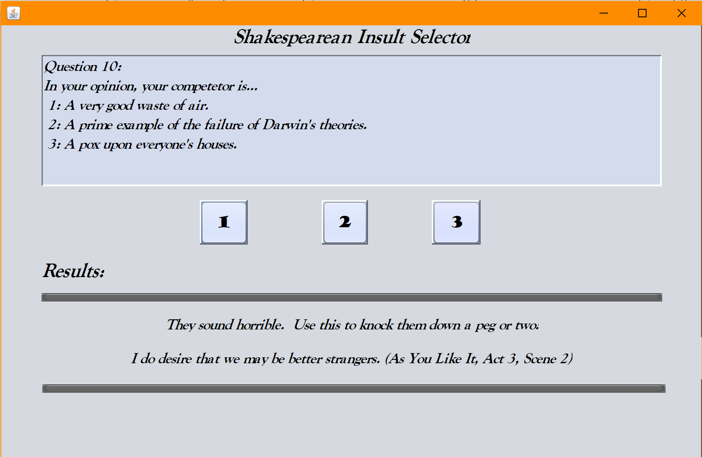

Click the “X” in the upper right hand corner of the window to close the program.

